**7. Multicarrier techniques and OFDM design/implementation**

**A narrowband channel – a channel in which the delay spread of multipath components are smaller than the symbol period, meaning the system will exhibit no inter-symbol interference**

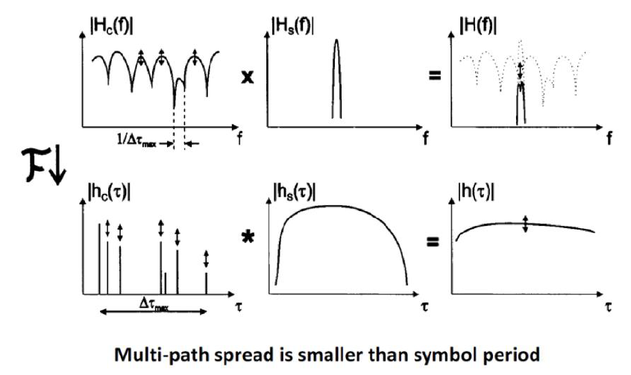

A wideband channel – a model is a channel in which the delay spread of the multi-path components are longer than the symbol period, meaning the multipath components span or several symbols creating ISI

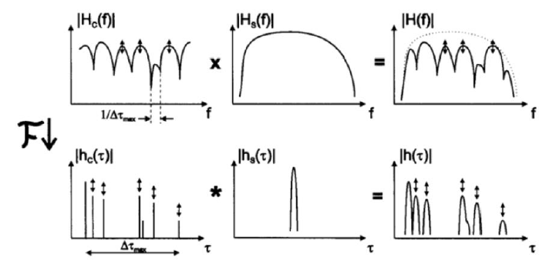

**ISI is also known as frequency selective fading**

Multicarrier modulation – an effective technique for reducing ISI without affecting the spectral efficiency of the system or requiring complex additions to the systems such as an equalizer

ISI introduces an error floor, which limits the maximum data rate

Equalization can remove or reduce ISI but is complex in practice

Multicarrier modulation may remove or reduce ISI by breaking the data stream into lower-rate sub streams modulated onto narrowband flat-fading sub-channels

**Effectively turning a frequency-selective fading wideband channel into multiple flat-fading narrowband channels**

**Multicarrier modulation is very adaptable as the modulation order of each channel can be set individually, allowing the system to adapt to fading channels**

General multicarrier modulation

A general multicarrier works by splitting a serial data stream into N parallel data streams, each of which is then modulated and translated to the frequency of its subchannel before being transmitted

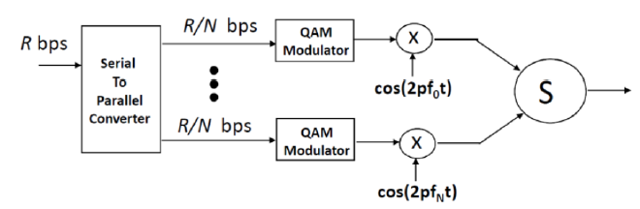

For ISI to be eliminated in each subchannel, the subchannel bandwidth must be smaller than the coherence bandwidth of the channel

Data is transmitted in parallel across multiple sub-channels

* This results in longer symbol periods than for serial systems

**OFDM**

A modulation technique which uses multicarrier modulation to limit the effects of ISI within a system without affecting the spectral efficiency significantly while simultaneously creating an adaptive system

An OFDM symbol is therefore at any time, a linear combination of the subcarriers at a given time

Orthogonal subcarriers:

A receiver should be able to easily separate the subcarriers. It turns out that by spacing the sub-channels equal to the symbol rate on each carrier, then the modulated signals are orthogonal and can be readily separated by correlation in a matched filter

Essentially, if the symbol period and subcarrier spacing match, the raised cosine pulses on each subcarrier in the time domain will result in a frequency domain SINC with zero-crossings in the center frequency of each subcarrier.

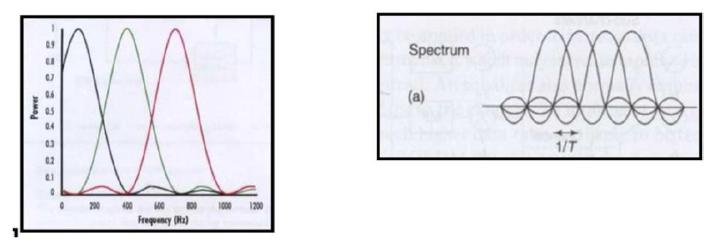

**Guard interval:**

OFDM also utilizes a guard interval called the cyclic prefix to further eliminate ISI as some ISI may still occur in the narrowband subcarriers if the data rate is high enough

* The guard time should exceed the longest multipath component to ensure ISI cannot affect actual data
* The receiver only looks at the nominal symbol period
  + Therefore, trades a minimal amount of spectral efficiency for elimination of ISI

Due to modulation and content, each symbol may vary from the previous in significant ways. These changes in phase, frequency and amplitude may cause distortion at the receiver. To combat this, the cyclic prefix applies a filter which smoothens the transition between symbols

OFDM utilizes the FFT and IFFT to efficiently modulate the subcarriers

In the transmitter, the frequency components of each subcarrier are constructed and passed through an inverse fft to convert it to the time domain for transmission

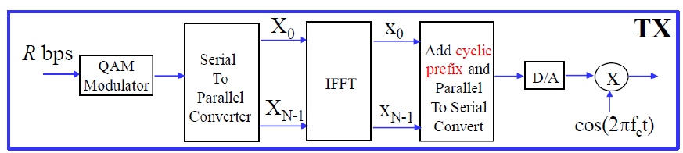

Receiver

In the receiver, a regular fft is used to convert to the time domain back to frequency components before combining.

The cyclic prefix ensures that the convolution is linear, and there is no interference between FFT blocks

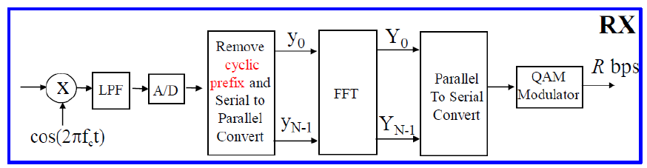

OFDM uses adaptive modulation QPSK or QAM

Forward error correction – performance of OFDM is quite bad if only a few subchannels are affected by fading, since the transmission is parallel and the overall BER of the system is close to that of the poorest sub-channel.

FEC is used to handle the poor BER in the presence of fading

* Convolutional codes in mobile systems

OFDM in fading channels

May be affected by:

* Multipath exceeding guard interval
* Doppler shift

Excess multipath delay

It will cause ISI, which leads to errors, hence the usage of FEC

Guard time is necessary to remove error floor due to ISI

Doppler shift

A shift in the sub-carrier frequencies, removing the orthogonality of the channels

Advantages of OFDM

An efficient way of dealing with multipath issues

In slowly time varying channels, the system capacity can be increased by adapting the data rate per subcarrier according to SNR of the particular subcarrier

Robust against narrowband interference

Enables single frequency networks (broadcast networks where multiple transmitters transmit the same signal simultaneously)

Disadvantages of OFDM

Very sensitive to frequency offsets and phase noise

Has a very large peak-to-average power ratio

Application examples: IEEE 802.11a

MIMO can be applied to MIMO systems by applying OFDM across spatial dimensions

**8. Principles of different radio archs and RF building blocks involved. Impact on system performance caused by nonlinear behavior of these RF building blocks**

Three types of radio architectures are described

AM detector receivers

Tuned-radio frequency

Direct-conversion receivers and superheterodyne receivers

Amplitude modulation detector receiver: use a bandpass filter to filter frequencies to a select carrier or channel, then pass the signal to a detector, which acts as a half-wave rectifier, before being passed to the amplifier which amplifies the signal to adequate drive levels (AM radio)

Tuned radio frequency

Utilizes a series of bandpass filters tuned to the received frequency, before passing the signal to an amplifier and a detector. This architecture utilizes to frequency translation, and therefore performs detection at the originally received signal frequency. This is very simple but eliminates the image frequencies introduced by mixers

Direct conversion receivers

A direct-conversion receiver converts the original signal to a much lower baseband frequency still carrying the modulation of the original signal. This frequency translation is performed by mixing the received signal with a signal of identical or near-identical frequency

Superheterodyne receivers

The heterodyne receiver architecture utilizes can incorporate multiple frequency translation stages to intermediary frequencies instead of directy to baseband. The LO used in a superheterodyne receiver is offset from the received frequency to ensure the mixing results in a signal above baseband.

Superheterodyne principles are used in most modern RF frontend architectures.

The following may be considered a general model of a superheterodyne architecture with the most common components, which are analyzed:

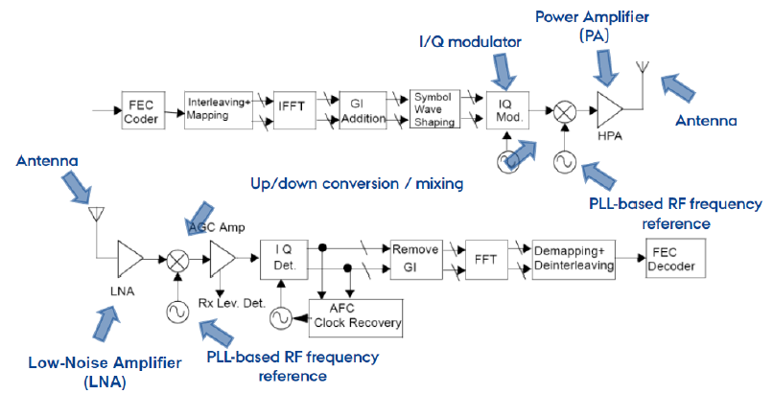

Building blocks

* Phase-locked loop rf frequency reference
* Up/down conversion
* I/Q modulator
* Power amplifier
* Low-noise amplifier
* Antenna

Phase-locked loop

Purpose is to control the reference oscillator in both the transmitter and receiver. The reference oscillator is used to up/down-convert the signal between the baseband frequency and the carrier frequency.

**PLL System Parameters:**

The system parameters that affect are relevant in the context of a PLL are:

* • **Channel spacing**: The frequency spacing of channels impose a limit on the accuracy of the frequency of the PLL output
  1. • **Lock time**: The lock time is the time a PLL needs to generate the target frequency with phase match (between PLL reference block and PLL feedback clock) after power is applied to the system. o This is especially critical in system which employ frequency hopping (such as Bluetooth)
  2. • **Frequency stability**: How stable is the reference frequency once reached
  3. • **Temperature range**
  4. • **Start**-**up time**

All of these parameters must be balanced between performance, price, complexity and power consumption.

**PLL Concept:**

The general concept of a PLL is that a reference signal is fed to a phase detector, which produces an error signal equal to the phase difference between the two signals. This error signal is then LP filtered (called the **loop filter**) and used to drive a voltage-controlled oscillator (VCO), which generates an output signal with a phase, which is then fed back to the input creating a **negative feedback loop**. If the desired output frequency is a multiple of the reference frequency, the output signal is divided before being fed back. This loop will ensure that drifts in the output phase compared to the input phase will be correct the VCO in the opposite direction to correct the error.



The output of the oscillator is a periodic signal, which may be sped up or slowed down to match the reference phase. Seeing as the VCO may start out far from the reference frequency, a practical phase detector may also take frequency difference into account.

**Common misconception in literature:** the purpose of the PLL is NOT to eliminate the phase difference, but instead it utilizes the phase difference to distinct the channel frequencies. The introduced phase difference is not a problem, because in the locked state, the phase difference will be constant for each channel frequency and therefore not affect the ability to select the channel frequency based on the VCO.

**PLL Design:**

A PLL may be both designed analogously and digitally. The general difference is whether the phase detector is implemented with an analog phase detector or a digital phase detector, and obviously whether the loop filter is analog or digital.

There are two approaches to designing a PLL: **integer-N** and **fractional-N** PLLs.

**Integer-N PLL:**

**Reference Frequency Constraint:**

An integer-N PLL is only capable of handling integer division. This imposes a constraint on the reference frequency and channel spacing, as the output frequency of the VCO can only be an integer multiple of the reference frequency, which means that the channel spacing must greater than or equal to the reference frequency for all channel frequencies to be achievable.

**Loop Filter Constraint:**

The loop filter is a LP filter intended to filter out the non-ideal harmonic ("spurious") components of the signal, and retain the DC component required to control the VCO. The cutoff frequency of this filter is limited by the reference frequency

Limiting the reference frequency, thereby limits the bandwidth of the filter, which imposes a time constant since the cutoff frequency will be increased with the increased reference frequency.

A solution is to operate with two filters - one fast, but non-accurate filter and a slower, accurate filter, which can be switched between.

**Fractional-N PLL:**

A fractional-N PLL is capable of handling fractional divisions, thereby achieving fractional multiples of the reference frequency at the output frequency. One way to design a fractional-N PLL is to add an integer division of the reference signal prior to being input to the phase detector. This can effectively achieve a 𝑁/𝑀 integer fractional multiple.

**Reference Frequency XTAL:**

The reference frequency is typically generated by an external XTAL crystal. The crystal must be carefully selected depending on what is required (serial/parallel, resistance, etc.)

The tolerance specifies the tolerated displacement of the reference signal used in the transmitter and receiver. This displacement causes an effective power loss in the received signal, and thereby a deterioration of the SNR.

The clocks generated by crystals in the transmitter and receiver with given uncertainties will cause the reference frequencies to be displaced. This implies that during a packet reception, the frequencies may drift apart within a packet, thereby imposing restrictions on the maximum packet length.

Up/Down-Conversion (Mixing)

Up- and down-conversion of signals are used in superheterodyne RF architectures to convert a signal at an intermediary frequency to and from the radio frequency.



The mixer creates to two signals from the mixing of two reference signals:

𝑓𝑚𝑖𝑥=𝑓𝐿𝑂±𝑓𝑟𝑒𝑓

When down-conversion, this can be a problem since typically only the lowest of the two intermediary frequencies are desired (the **difference signal** 𝑓𝐿𝑂−𝑓𝑟𝑒𝑓). The unwanted **sum signal** (𝑓𝐿𝑂+𝑓𝑟𝑒𝑓) is called the **image signal** and should be filtered through a LP or BP filter.

Additional images are also produced in the primary intermediary frequency as a result of harmonics in the LO combining with the sum frequency, but this seems out of scope for the course.

The primary parameters of mixers are the following:

* • Image rejection: ability to reject images in the down-conversion
* • Dynamic range: range of signal levels within linear range of mixer (typically between thermal noise/noise figure in the lower end and 1dB compression point in the upper end)
* • Harmonics generation
* • LO suppression/leakage

I/Q-modulator

The I/Q-modulator is used to control the amplitude, frequency and phase of a carrier signal by manipulating the amplitudes of in-phase (0°) and quadrature (+90°) components of said signal.

A cosine signal may given by: 𝐴cos(2𝜋𝑓𝑐𝑡+𝜙)=𝐼cos(2𝜋𝑓𝑐𝑡)−𝑄sin(2𝜋𝑓𝑐𝑡)

Therefore, any carrier sine wave can be constructed from the addition of these two components.

Since sine and cosine waves have a phase difference of 90°, two carrier must be introduced – a reference carrier and a 90° separated carrier.



The parameters of a I/Q modulator are:

* • Amplitude- and phase imbalances
* • Dynamic range
* • Harmonics generation

Amplifier (PA+LNA)

The purpose of the power amplifier (PA) is to amplify the digitally modulated signal in the transmitter to the level required for transmission in the antenna. The purpose of the low-noise amplifier (LNA) is to amplify the signal received by the receiver antenna to a level, which is sufficient for processing the signal in the receiver.

The primary parameters of amplifiers are:

* • Gain
* • Linearity vs non-linearity
* • Efficiency

**Linearity:**

Amplifiers have a linear area in which they are approximately linear. This area corresponds to range of input levels, for which the output is linearly proportional to the input and the gain. Outside this range, the gain of the amplifier will decrease, which means the efficiency of the amplifier will decrease. The goal is therefore to operate an amplifier within its linear range.

The linear range of an amplifier is typically described by its 1dB compression point, which is the input level at which the actual gain is 1dB lower than the extrapolated linear gain.



**Non-linearity:**

Due to imperfections in the components, all amplifiers generate higher-order harmonics in the output signal.

The output of a PA may be given by: 𝑉𝑂(𝑡)=𝛼1𝑉1(𝑡)+𝛼2𝑉12(𝑡)+𝛼3𝑉13(𝑡)

Where the first element is called the **first order content** and the others are called the **second** and **third order content** respectively. From the formula it apparent that 2nd-order content increased at a squared rate compared to the 1st order content, and that the 3rd order content increase at a cubed rate compared to the first order content. The higher order content can be filtered out since the frequencies of the components are distinct from the fundamental component, but a problem arises in the presence of intermodulation products.

This property of an amplifier is described by the intercept points, which are the point at which the extrapolated higher order content intercept with the extrapolated 1st order content.



**Intermodulation:**

When two or more signals are input to an amplifier simultaneously, the second-, third-, and higher-order intermodulation components are caused by the sum and difference products of each of the fundamental input signals and their associated harmonics. For example, when two perfect sinusoidal signals, at frequencies f1 and f2, are input to any nonlinear amplifier, the following output components will result:

* • fundamental: f1, f2
* • second order: 2*f*1, 2*f*2, *f*1 +*f*2, *f*1 - *f*2
* • third order: 3*f*1, 3*f*2, 2*f*1 ±*f*2, 2*f*2 ±*f*1 +higher order terms

Under normal circuit operation, the second-, third-, and higher-order terms are usually at a much smaller signal level than the fundamental component and, in the time domain, this is seen as distortion. Note that, if f1 and f2 are very close in frequency, the 2 f1- f2 and 2f2 -f1 terms fall very close to the two fundamental terms. Third-order distortion products are, therefore, much more difficult to eliminate through filtering once they are generated within an amplifier.

Intermodulation is a factor in RF receivers, as they will often encounter multiple signals at the input either through design or interference.

**Low-Noise Amplifier (LNA):**

All components are inherently noisy. The added noise of a components is described using its noise figure *F*. 𝐹=𝑃𝑁𝑜𝑃𝑁𝑖𝐺𝐴=𝑃𝑆𝑖𝑃𝑁𝑖⁄𝑃𝑆𝑜𝑃𝑁𝑜⁄

The total noise figure of cascaded components is given by: 𝐹=𝐹1+𝐹2−1𝐺𝐴1

As the LNA will amplify all noise introduced prior to its input, the loss from high noise on the input of the LNA is significant.

The goal is to design a LNA with high gain (G) and low noise figure (F).

**Antenna:**

The antenna transmits the RF signal, and should be designed with the following parameters in mind:

- Design (PCB/wire/etc.)

* 1. - Directivity: in which direction is the antenna focused o The ratio of radiation intensity in a given direction from an antenna to the radiation intensity averaged over all directions, is termed as directivity.
  2. o The directivity of a non-isotropic antenna is equal to the ratio of the radiation intensity in a given direction to the radiation intensity of the isotropic source.
  3. - Beam width

Not a lot to this section, since it is only briefly mentioned and should perhaps be skipped altogether.